Pre-Lab 4: Mesh Analysis Methods
- $I_{2}$ in terms of $I_{1}, R_{2}, R_{3}$. $I_{1}$ gets absorbed in when solving for $I_{2}$. The hand calculations are in the next page.
$$I_{2}=\frac{\left(10\frac{R_{3}}{R_{2}+R_{3}}-5\right)}{\left(-\frac{R_{3}^{2}}{R_{2}+R_{3}}+\left(R_{2}+R_{3}\right)\right)}=-375 μ\text{A}$$
- Current values for $I_{1}$ and $I_{2}$
$$I_{1}=\frac{I_{2}R_{3}+10}{R_{2}+R_{3}}=875 μ\text{A}$$
Matrix operations can also be used.
$Let \text{col 1}$ be $I_{1}$ and $\text{col} \text{2}$ be $I_{2}$, solving the system equations using matrix operations:
$$\left[\begin{matrix}\left(R_{1}+R_{3}\right) & -R_{3} & 10 \\ -R_{3} & \left(R_{2}+R_{3}\right) & -5\end{matrix}\right]=\left[\begin{matrix}11 \text{kΩ} & -1 \text{kΩ} & 10 \\ -1 \text{k}\text{Ω} & 11 \text{k}\text{Ω} & -5\end{matrix}\right]\underset{⇒}{\text{rref}}\left[\begin{matrix}1 & 0 & 875 \text{μA} \\ 0 & 1 & -375 \text{μA}\end{matrix}\right]$$

- Circuit Lab simulations
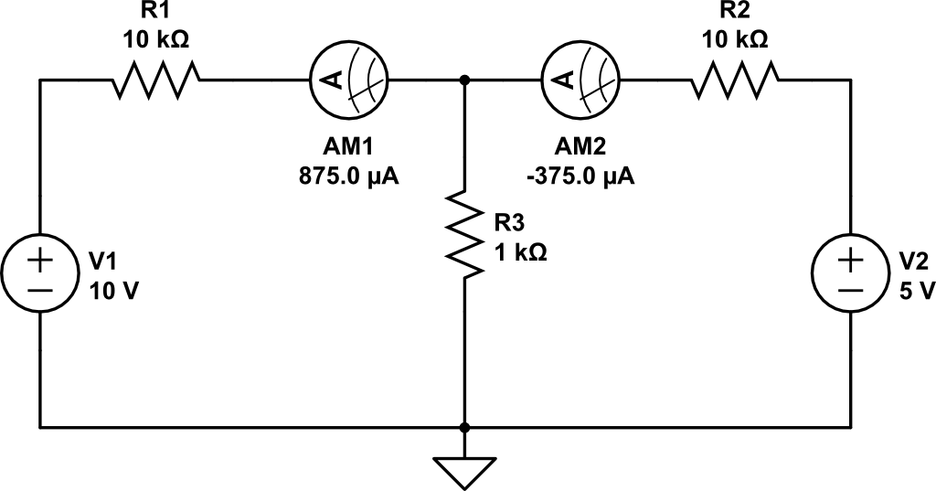

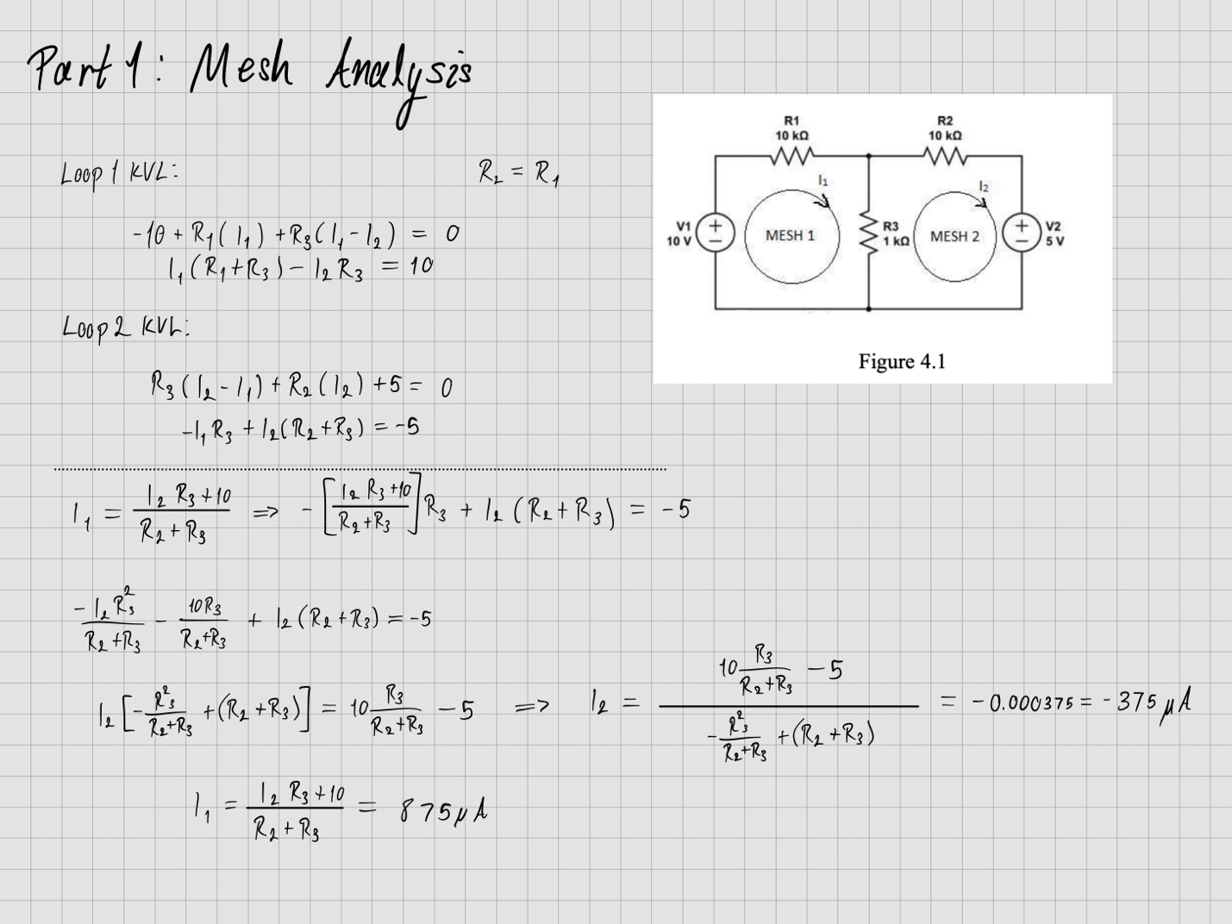
Hand calculations for A

Part 2

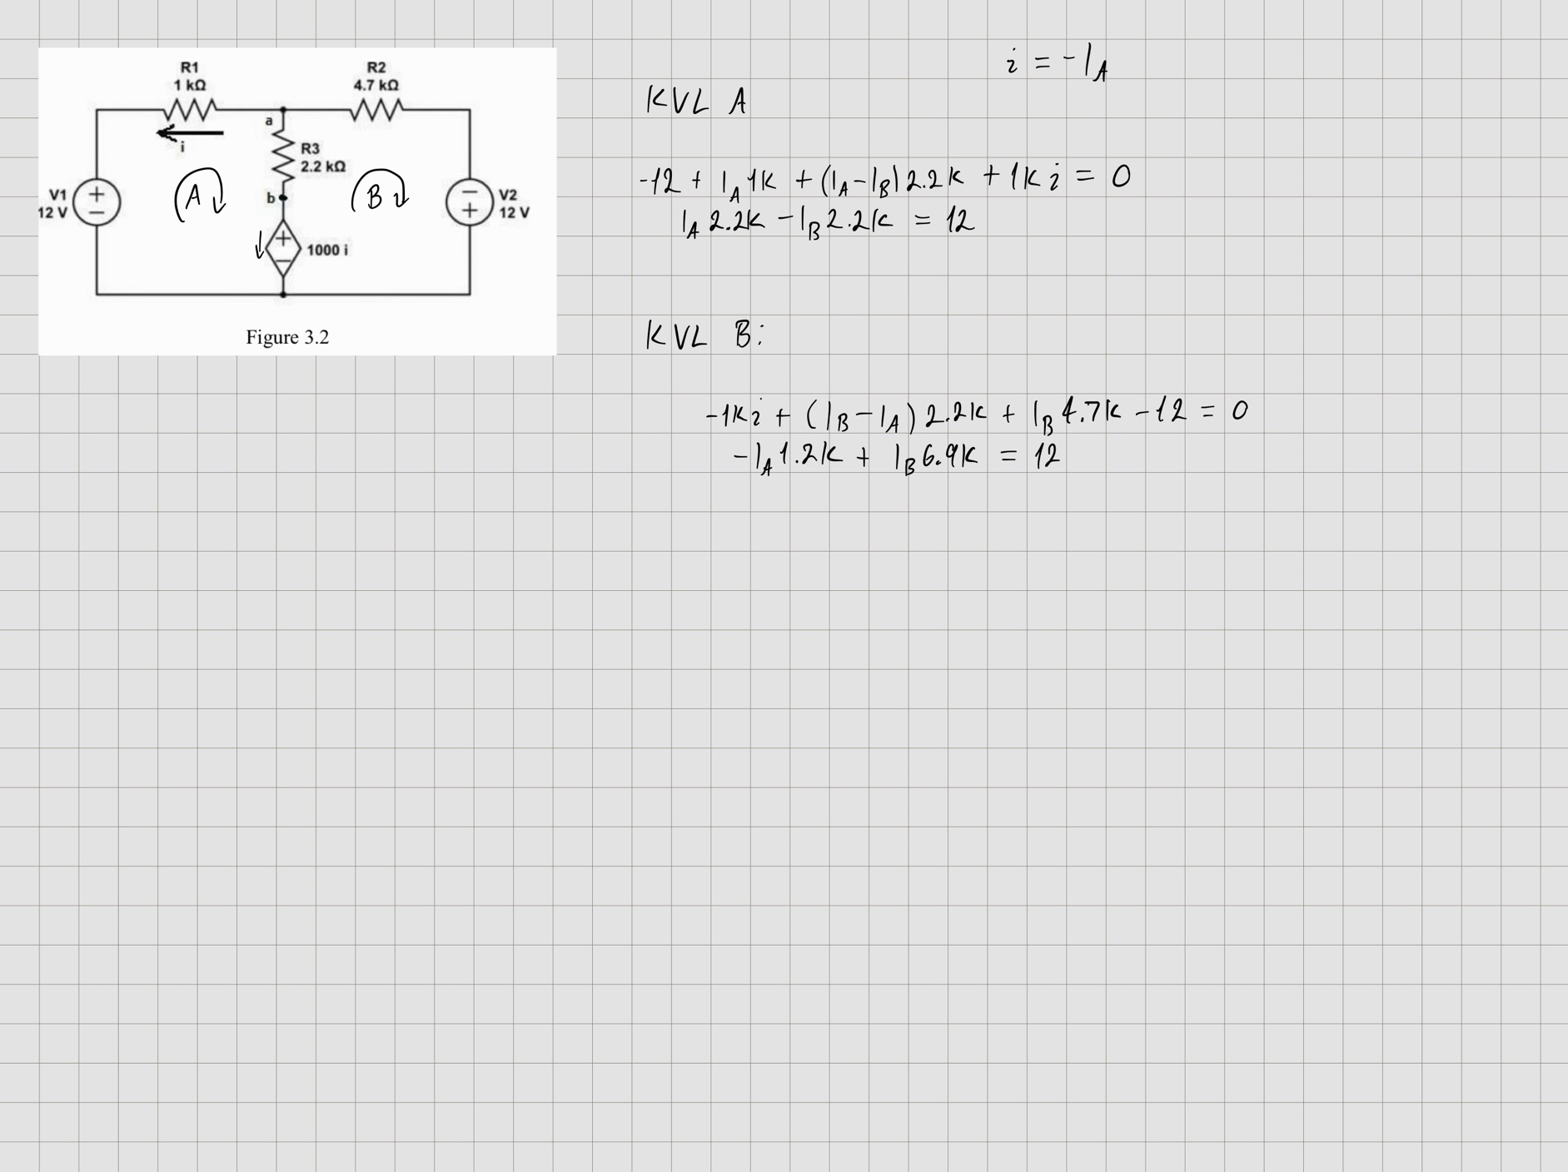

Solve using matrix operations where $\text{col} 1$ is $I_{A}$ and $\text{col} 2$ is $I_{B}$
$$\left[\begin{matrix}2200 & -2200 & 12 \\ -1200 & 6900 & 12\end{matrix}\right]\underset{⇒}{\text{rref}}\left[\begin{matrix}1 & 0 & 8.708 \text{mA} \\ 0 & 1 & 3.253 \text{mA}\end{matrix}\right]$$
Because $i=-I_{A}$, $i=-8.708 \text{mA}$

- The voltage $V_{ab}=R_{3}\left(I_{A}-I_{B}\right)=2.2 \text{kΩ}\left(8.708 \text{mA}-3.253 \text{mA}\right)=12 \text{V}$

